EMERGING METHODS FOR EARLY DETECTION OF FOREST FIRE

TEAM ID: PNT2022TMID29475

1. **INTRODUCTION**
   1. Project Overview
   2. Purpose
2. **LITERATURE SURVEY**
   1. Existing problem
   2. References
   3. Problem Statement Definition
3. **IDEATION & PROPOSED SOLUTION**
   1. Empathy Map Canvas
   2. Ideation & Brainstorming
   3. Proposed Solution
   4. Problem Solution fit
4. **REQUIREMENT ANALYSIS**
   1. Functional requirement
   2. Non-Functional requirements
5. **PROJECT DESIGN**
   1. Data Flow Diagrams
   2. Solution & Technical Architecture
   3. User Stories
6. **PROJECT PLANNING & SCHEDULING**
   1. Sprint Planning & Estimation
   2. Sprint Delivery Schedule
   3. Reports from JIRA
7. **CODING & SOLUTIONING (Explain the features added in the project along with code)**
   1. Feature 1
   2. Feature 2
   3. Database Schema (if Applicable)
8. **TESTING** 
   1. Test Cases
   2. User Acceptance Testing
9. **RESULTS**
   1. Performance Metrics
10. **ADVANTAGES & DISADVANTAGES**
11. **CONCLUSION**
12. **FUTURE SCOPE**
13. **APPENDIX**

Source Code

GitHub & Project Demo Link

**1.INTRODUCTION**

**1.1 Overview**

Forests, which are diverse centers of flora and wildlife and create 1/3 of the world's oxygen, are at risk of forest fires, both natural and man-made. The precaution of averting such a massive devastating flare can save many animals and the environment. Protecting forests before they are harmed is a method of repaying Mother Nature's everlasting gift. Wildfires are one of the biggest catastrophes faced by our society today causing irrevocable damages. These forest fires can be man-made or caused by mother nature by different weather conditions, torrential winds. These fires cause damages not only to the environment they also destroy vast homes and property.

**1.2 Purpose**

Forest fires have become a major threat around the world, causing many negative impacts on human habitats and forest ecosystems. Climatic changes and the greenhouse effect are some of the consequences of such destruction. Interestingly, a higher percentage of forest fires occur due to human activities.

**2.LITERATURE SURVEY**

**2.1 Existing problems**

Every year, there are an estimated 340,000 premature deaths from respiratory and cardiovascular issues attributed to wildfire smoke.

The increasing frequency and severity of wildfires pose a growing threat to biodiversity globally. Individuals, companies and public authorities bear great economic costs due to fires. In order to reduce all these, we need to detect the forest fire at an early stage and prevent it.

Some of the existing solutions for solving this problem are:

**Technology**

The present technology includes particle and smoke detection systems, which are commonly used in facilities and families. These systems detect moisture in a space and determine whether the current atmosphere is safe or if an alarm should be triggered.

The same way that a fire alarm works by spraying water throughout the room to put out the fire.

**Fire fighter**

To tackle fire problems, highly trained humans are used. Firefighters employ techniques and trucks to suppress forest fires throughout the conditions.

The priority of a firefighter is to protect people and reduce the number of people killed or injured by fire. Firefighting and property damage are the second and third priorities, respectively.

**2.2 References**

1. Environment Setup: https[youtube.com/watch?v=5mDYijMfSzs](https://www.youtube.com/watch?v=5mDYijMfSzs)
2. Forest fire Dataset: [https://drive.google.com/drive/folders/1vq8TRFWE7WH7_https://drive.google.com/drive/folders/1vq8TRFWE7WH7_-dsqKAmvjJAsaxx-kPQ?usp=sharingdsqKAmvjJAsaxx-kPQ?usp=sharing](https://drive.google.com/drive/folders/1vq8TRFWE7WH7_-dsqKAmvjJAsaxx-kPQ?usp=sharing)
3. Keras Image Processing Doc: <https://keras.io/api/preprocessing/image/>

1. Keras Image Dataset from Directory Doc: [https://keras.io/api/preprocessing/image/#imagedatasetfromdirect ory-function](https://keras.io/api/preprocessing/image/#imagedatasetfromdirectory-function)

1. CNN using TensorFlow:<https://www.youtube.com/watch?v=umGJ30-15_A>

1. OpenCV Basics of Processing

Image:<https://www.youtube.com/watch?v=mjKd1Tzl70I>

1. Flask Basics:<https://www.youtube.com/watch?v=lj4I_CvBnt0>

1. IBM Academic Partner Account Creation: [https://www.youtube.com/watch?v=x6i43M7 BAqE](https://www.youtube.com/watch?v=x6i43M7BAqE)

**2.3Problem Statement Definition**

To prevent destroying of forest plants, trees and to save the lives of birds, animals and human lives

Nature causes - Many forest fires start from natural causes such as lighting which set trees on fire.

Artificial causes - Forest fire can also occur by man-made fires

Forest fires are a major environmental issue, creating economic and ecological damage while endangering animal human lives and it destroys all plants and trees.

The issue can be identified when the fire occur in that region, then automatically the system can detect fire

**3.IDEATION & PROPOSED SOLUTION**

**3.1 Empathy Map Canvas**

An empathy map canvas is a more in-depth version of the original empathy map, which helps identify and describe the user's needs and pain points.

**3.2 Ideation & Brainstorm**

organizing the brainstorming session and prioritize the top 3 ideas based on the feasibility & importance.



**Step-2: Brainstorm,Idea,Listing and Grouping**

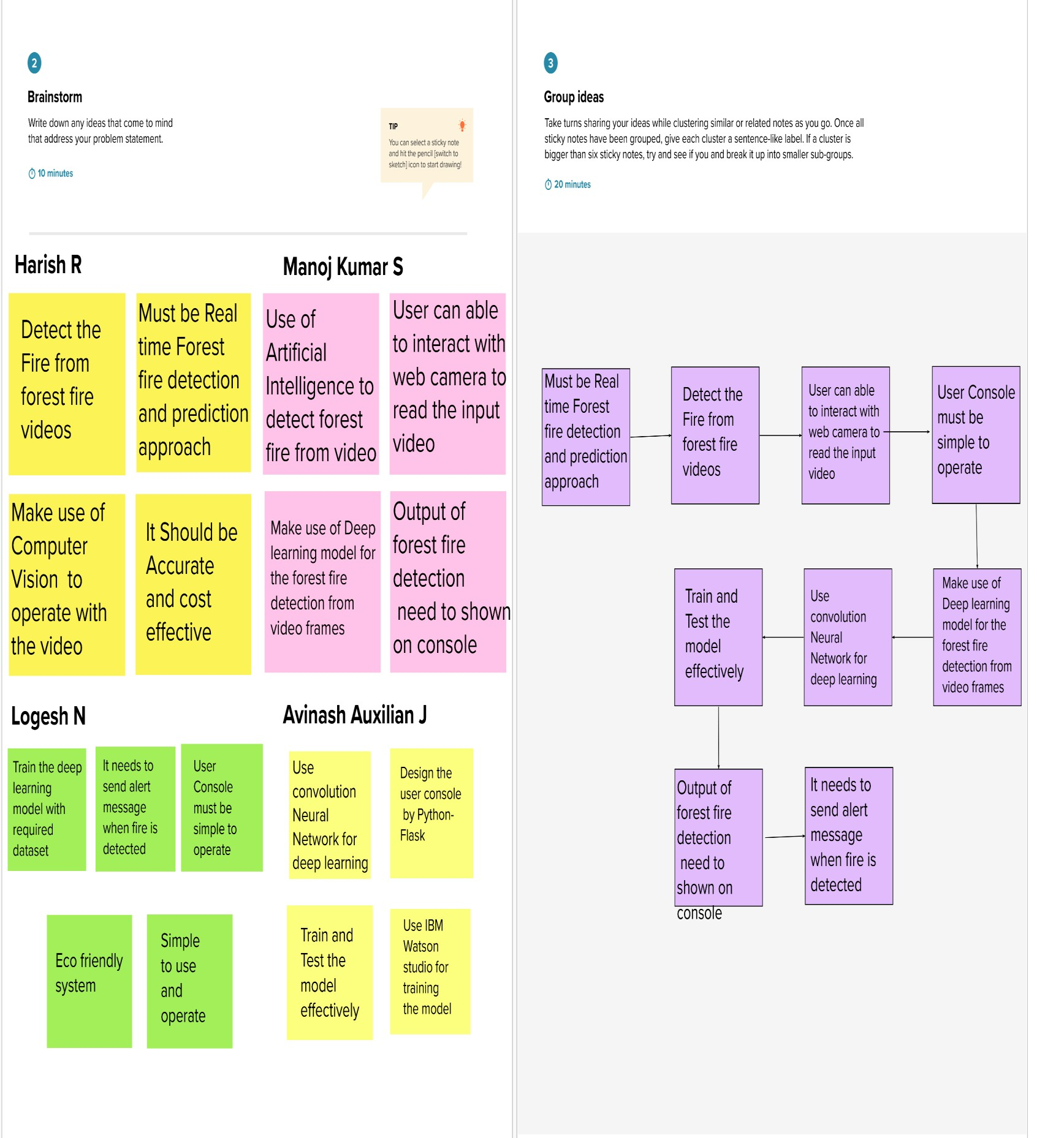

**Siva kumar R**

**Manikandan N**

**Sujith S**

**Harish k**

**3.3 Proposed solution**

The following paper describes the system to detect fire before becoming a big flame of destruction:

* Among the visual signs of fire, smoke appears earlier than the flames in many cases, and quickly reaches the environment.
* To build a system to detect the fire in woods through image processing.
* In order to solve this problem, the deep learning technology is applied to learn and extract features of forest fires adaptively.
* Fire detection in its early stages is of a great importance in different environmental related applications.
* Due to developments in digital cameras and video processing techniques, there is a significant tendency to switch to traditional fire detection methods with computer based systems.

**3.4 Problem Solution fit**

Early detection of fire-accidents can save innumerable lives along with saving properties from permanent infrastructure damage and the consequent financial losses. The environmental challenges the world faces nowadays have never been greater or more complex.

To prevent injuries and property damage, advanced technology requires appropriate methods for detecting fires as quickly as possible. In this study, to reduce the loss of human lives and property damage.

It is cost effective technique for the fire detection when compared to existing solution.

Customer can be easy to understand by using basic computer knowledge In order to solve this problem, the deep learning technology is applied to learn and extract features of forest fires adaptively.

The limited learning and perception ability of individual learners is not sufficient to make them perform well in complex tasks.

learners tend to focus too much on local information, namely ground truth, but ignore global information, which may lead to false positives. In this paper, a novel ensemble learning method is proposed to detect forest fires in different scenarios

**4. REQUIREMENTS ANALYSIS**

**4.1 Functional Requirements**

Hardware Requirements:

|  |  |
| --- | --- |
| Operating System | Windows, Mac, Linux |
| CPU (for training) | Multi Core Processors (i3 or above/equivalent) |
| GPU (for training) | NVIDIA AI Capable / Google's TPU |
| Webcam | Integrated or External with Full HD Support |

**Software requirements :**

|  |  |
| --- | --- |
| Python | v3.9.0 or above |
| Python Packages | flask, TensorFlow, OpenCV-python, keras, NumPy, pandas, Virtual Net, pillow |
| Web Browser | Mozilla Firefox, Google Chrome or any modern web browser |
| IBM Cloud (for training) | Watson Studio- Model Training & Deployment as  Machine Learning Instance |

**4.1 Non-Functional Requirements**

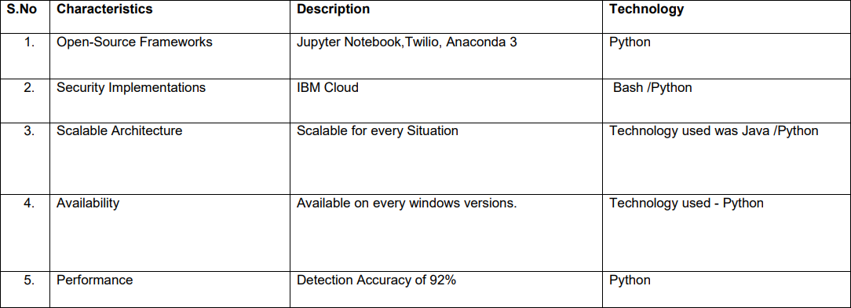

**5.PROJECT DESIGN**

**5.1Data Flow Diagrams**

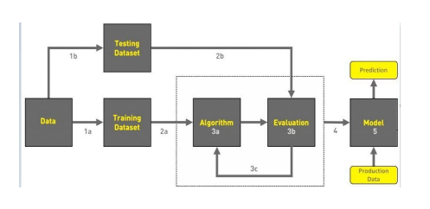

**5.2 Solution & Technical Architecture**

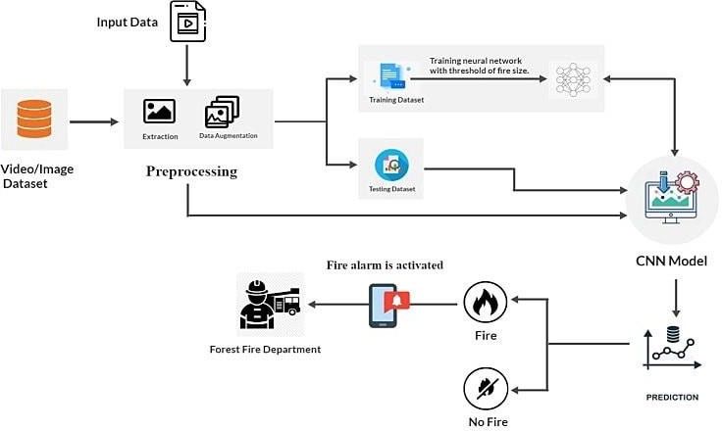

**5.3User Stories**

Fires in natural areas are getting out of control due to drought or wind, and the risk of danger to people, animals, nature and infrastructure is growing. But how can fires be detected and localized at an early stage to minimize or even avoid serious damage? With image processing and artificial intelligence, such challenges can be mastered. Instead of elaborately programming a solution, neural networks and deep learning algorithms teach an image processing system to see, recognize and verify objects – in this case smoke. Furthermore, AI enables a corresponding image processing system to draw conclusions from what it learns.

The ADELIE system is composed of at least two surveillance points that are networked together. Each surveillance point consists of two detection cameras and an additional camera that serves to eliminate doubts. Four Gigabit Ethernet cameras from IDS are integrated per ADELIE detection camera. Thus, a total of eight IDS cameras are used per surveillance point. These monitoring points allow 360° monitoring, with each azimuth visualized approximately every two minutes. Automatic monitoring of the observed natural area takes place around the clock, 24 hours a day, seven day a week.

The system is connected to a processing unit whose software contains artificial intelligence-based image processing algorithms. It registers, compares and analyses the images provided by the cameras. Long before a tree burns, smoke is released from the surrounding grass and scrub. By comparing the images and using taught-in features, the system detects the rising smoke. As soon as this smoke is visible from the monitoring point, ADELIE triggers an alarm. This phase is called automatic fire and forest fire detection.

They permanently observe a specific forest area within a radius of up to 20 kilometers. Depending on the system, they need a maximum of two minutes to monitor a radius of 360 degrees. With the help of algorithms specially developed by Paratonic, the system can recognize and localize fire sources on the basis of the recorded images and to provide real-time information for appropriate options for action. ADELIE ensures efficient planning and control of the fire brigade to protect our living space and, finally, to protect buildings, power lines, telecommunication lines, road or rail infrastructure.

**6. PROJECT PLANNING & SCHEDULING**

**6.1Sprint Planning & Estimation**

**Sprint 1**

Importing the ImageDataGenerator libraries, Define Parameters/Arguments for ImageDataGenerator class, Applying Image Data Generator Functionality to trainset and test set.

**Sprint 2**

Importing the model building libraries, Initializing the model, Adding CNN layers, Adding Dense layers, Configuring the learning Process, Train the model, Save the model, Predictions.

**Sprint 3**

* + Create an account in Twilio service and buy a number then get authentication ID and token.
  + Use of OpenCV video processing technique for the detection of forest fire through video.
  + Load our trained model and give an demo video as a input for detecting the fire.
  + If the fire is detected alert message is sent to the registered mobile number.

**Sprint 4**

* + In this we need to integrate the trained model with Flask along HTML.
  + Design the HTML page with both the prediction of image and video analysis.
  + When user uploads a image, the model can predict the fire and displayed on the webpage

**6.2 Sprint Delivery Schedule**

**6.3Reports from JIRA**

**7.CODING & SOLUTIONING (Explain the features added in the project along with code)**

**7.1Feature 1**

In Feature 1 module we have made data collection and Image preprocessing for and Model training.

**importing Required Libraries:**

import keras

from keras.preprocessing.image

import ImageDataGenerator

import matplotlib.pyplot as plt

import numpy as np batch_size = 32

**image resizing and preprocessing:**

train_datagen = ImageDataGenerator(shear_range=0.2,rotation_range=180,zoom_range=0.2, horizontal_flip=True,)

val_datagen = ImageDataGenerator( rescale=1./255)

train_generator = train_datagen.flow_from_directory( 'train_set/',

target_size=(150, 150), batch_size=batch_size, class_mode='binary')

val_generator = val_datagen.flow_from_directory( 'test_set/',

target_size=(150, 150), batch_size=batch_size, class_mode='binary')

**Creating the sequential model:**

from keras.models import Sequential

from keras.layers import Convolution2D

from keras.layers import MaxPooling2D

from keras.layers import Activation

from keras.layers import Dropout

from keras.layers import Flatten

from keras.layers import Dense

model=Sequential()

model.add(Convolution2D(32,(3,3),input_shape=(150,150,3))) #Convolutional 2D Layer

model.add(Activation('relu'))

model.add(MaxPooling2D(pool_size=(2,2))) # MaxPooling Layer

model.add(Flatten()) #Flatten Layer to make a array

model.add(Dense(150))

model.add(Activation('relu'))

model.add(Dropout(0.5))

model.add(Dense(1))

model.add(Activation('sigmoid'))

model.compile(

loss='binary_crossentropy', optimizer='adam', metrics=['accuracy'])

**Model Summary:**

Model. Summary()

**7.2Feature 2**

from keras.models import load_model from keras.preprocessing import image import numpy as np

import cv2

from PIL import Image, ImageOps model=load_model("forest1.h5") from twilio.rest import Client from playsound import playsound model=load_model('forest1.h5') video=cv2.VideoCapture(0) name=['forest','with fire']

account_sid=' AC8bcdde6842f897fd45c31e76fe33a956' auth_token=' abcee00c7b2aeaece954b6240000a3a5'

client =Client(account_sid,auth_token) message=client.messages \

.create(

body='-------Forest Fire is detected,Stay Alert !!! ',

from_='+ 18583303294',to='+919360898924')

print(message.sid), print("Alert Message sent")

**8.TESTING**

**8.1 Test Cases& 8.2 User Acceptance Testing**

**Testing with input video recording from user end:**

import cv2

import numpy as np

from keras.preprocessing import image from keras.models import load_model from twilio.rest import Client

from playsound import playsound model=load_model('forest1.h5') video=cv2.VideoCapture(0) name=['forest','with fire'] while(True):

ret,frame=video.read() cv2.imshow('frame',frame) cv2.imwrite('image.jpg',frame)

img=image.load_img('image.jpg',target_size=(64,64)) x=image.img_to_array(img) x=np.expand_dims(x,axis=0)

pred=model.predict(x) index=np.argmax(pred) if index==0:

account_sid=' AC8bcdde6842f897fd45c31e76fe33a956' auth_token=' abcee00c7b2aeaece954b6240000a3a5'

client =Client(account_sid,auth_token) message=client.messages \

.create(

body='-------Forest Fire is detected,Stay Alert !!! ',

from_='+ 18583303294',to='+919360898924')

print(message.sid) print('Fire detected') print("Alert Message sent!")

playsound('tornado-siren.mp3')

else:

print('No Danger') cv2.imshow("image.jpg",frame)

if cv2.waitKey(2) & 0xff == ord('a'): break

video.release() cv2.destroyAllWindows()

**output for user input video stream**

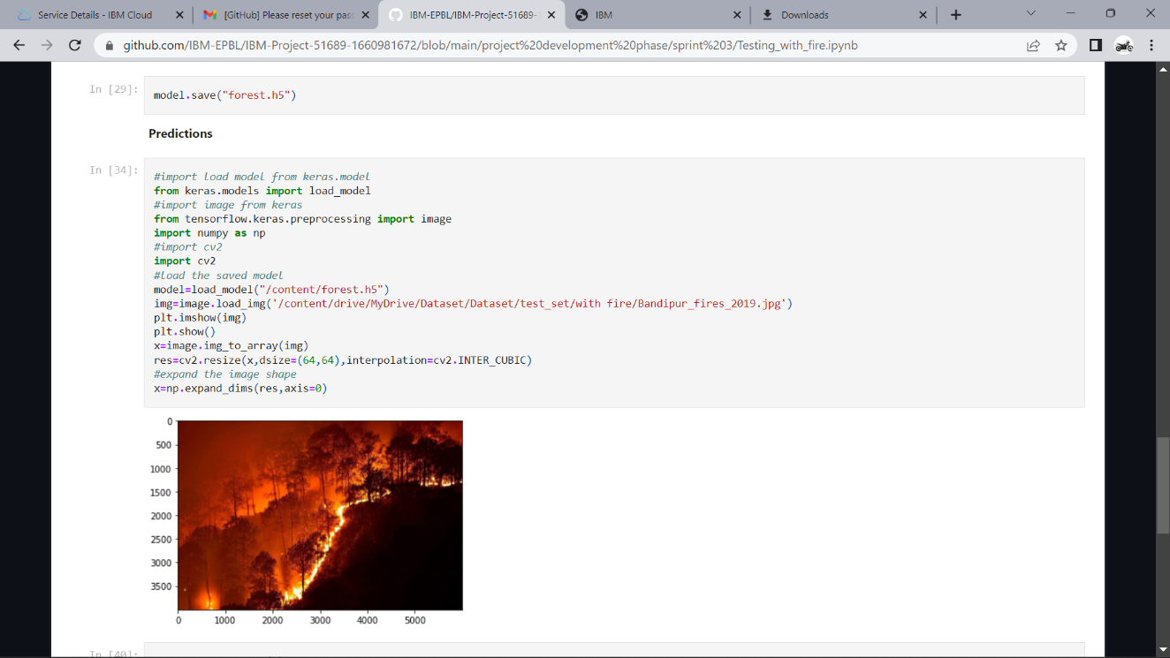

**9.RESULTS**

**Performance Metrics:**

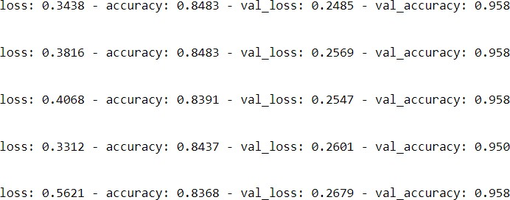

**10.ADVANTAGES & DISADVANTAGES**

**ADVANTAGES:**

* The proposed model can be used in combination with a night camera and a thermal camera in a forest to identify tiny fire signs.
* More datasets and images can be used to train for a more accurate outcome when detecting flame destruction on ability.
* model can be implemented in mobile applications for camping experience enthusiasts.

**DISADVANTAGES:**

* + The model works for limited information.
  + The accuracy is low because to the limited quantity/quality of photos in the dataset, but this may easily be increased by changing the dataset.
  + The small amount of fire amount detection can also cause to trigger the alarm.

**11. CONCLUSION**

Forest fires are a major cause of rain forest and savanna degradation. This model will aid in minimising destruction by anticipating it to the system, allowing individuals to react more quickly and prevent it.

The proposed methodology would deconstruct the threat to the environment by converting the image collected into signals that will trigger an alarm.

This system transmits video images to a model, which recognises them and determines whether or not to send a threat alert. The model extracts data from video feeds and defines image processing into RGB data for signal response modelling.

**12.FUTURE SCOPE**

The availability of fire-fighting technology brings us one step closer to new AI for detection and security in the forest and at home. With the addition of a motion sensor, the technology can simply expand to compact decision-making with the addition of new software and hardware.

The system is utilized as a drone and surveillance system UAV to expand the surveillance area and detect heat signatures in order to identify human from fire plasma signatures.

**13.APPENDIX**

**Source Code:**

Source Code :https://github.com/IBM-EPBL/IBM-Project-33821- [1660227659/blob/main/Final%20Deliverables/EntireModel.ipynb](https://github.com/IBM-EPBL/IBM-Project-33821-1660227659/blob/main/Final%20Deliverables/EntireModel.ipynb)

**GitHub & Project Demo Link**

GitHub: <https://github.com/IBM-EPBL/IBM-Project-51689-1660981672>

Demo Link: <https://drive.google.com/file/d/16SyKMNwNUoCMS91gWLmD2LITE6kxqYuJ/view?usp=sharing>